**CSE523** Machine Learning

Project: Shipment Price Prediction

Weekly Project Report: March 25, 2023

Team: **Revolution**

|  |  |
| --- | --- |
| Team Members | Enrolment-ID |
| Deep Patel | AU2040250 |
| Roshni Navdiya | AU2040114 |
| Aditya Padhariya | AU2040151 |
| Keval Parmar | AU1940133 |



* **Task Performed this week:**

1. By calculating order of country using freight cost to find top locations of freight cost.
2. Calculating freight cost parameter using mode of transportation.

* **Outcomes of the tasks performed:**

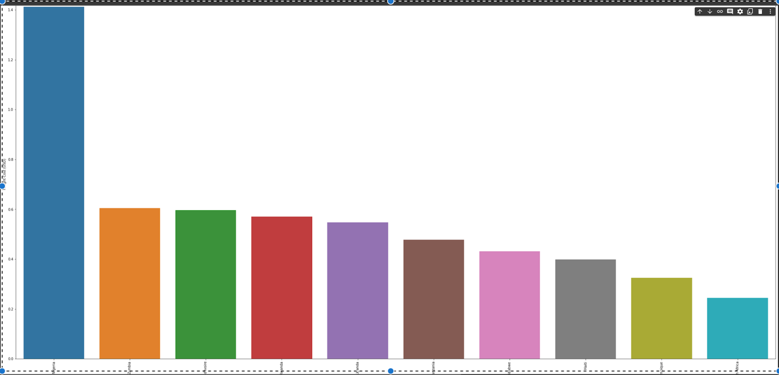

* **Tasks to be performed in the upcoming week:**

1. Will be calculating adjusted R2 value to finally decide which machine learning algorithm to use.
2. Manufacturing sites to be captured according to the orders and freight cost.
3. Test run the selected model on the selected parameters.